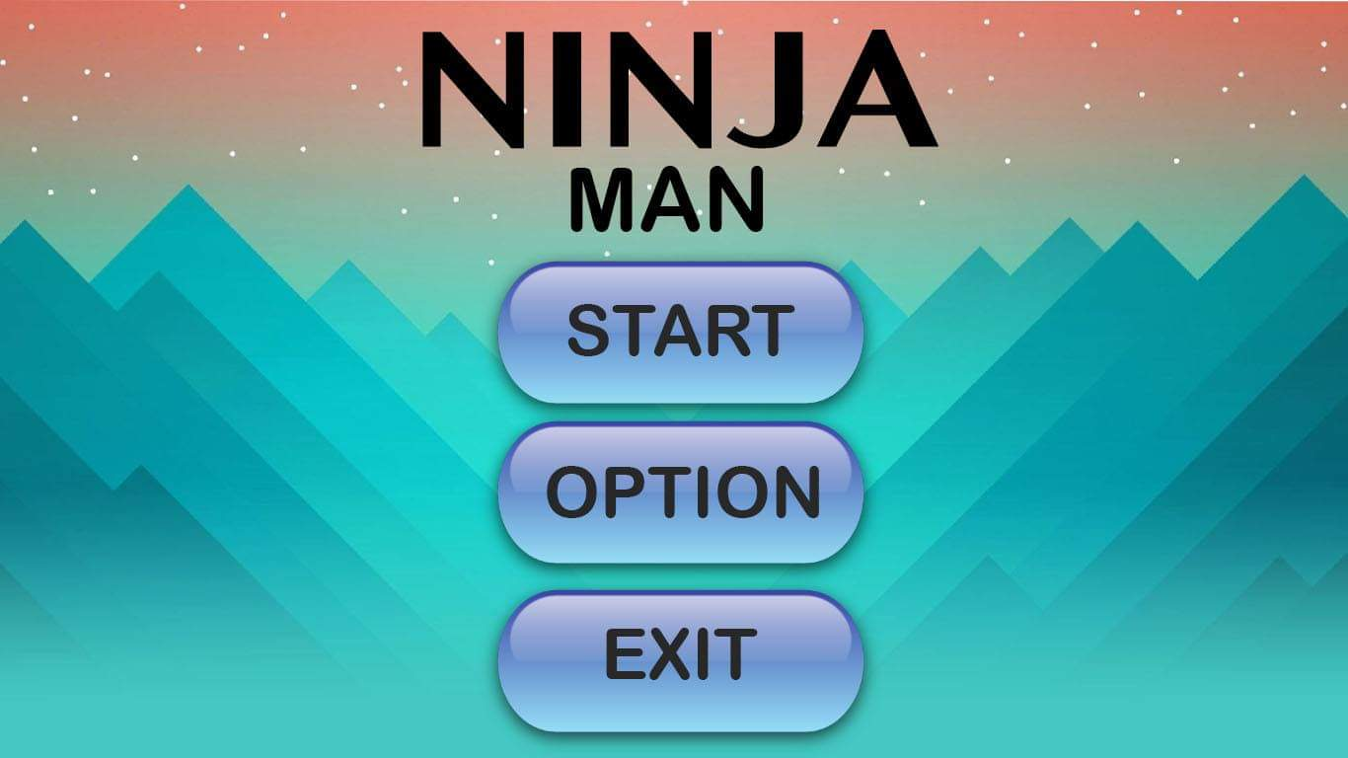NINJA MAN

SUBMITTED BY:

ALDRIDGE HUGH A. MENDOZA

SUBMITTED TO:

MR. RN SANTOS

HCI INSTRUCTOR

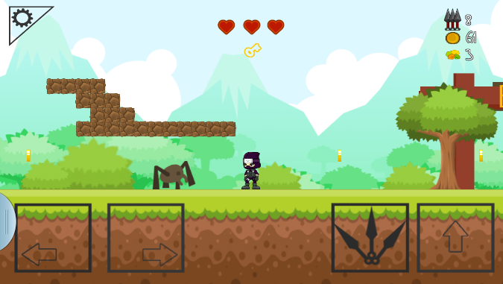

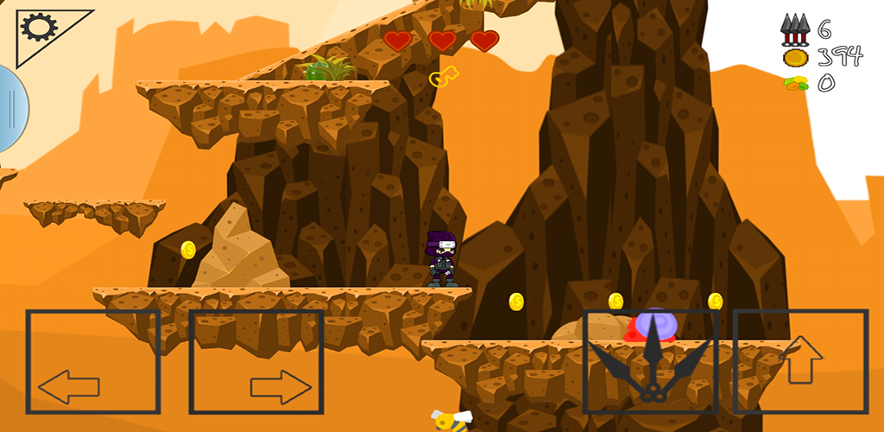

GENRE: ACTION, ADVENTURE

TARGET: AGES 10 AND UP

RATING: RATED E 10+

NUMBER OF PLAYERS: SINGLE PLAYER

PLATFORM: ANDROID AND IOS

GAMEPLAY:

THE PLAYER MUST COLLECT ENOUGH COINS TO CLEAR THE STAGE. PLAYER NEED TO KILL THE MONSTER THAT HE/SHE WILL ENCOUNTER DURING THE GAME. IT ONLY HAS A 3 LIVES AND 3 GIVEN KUNAI BUT IT WILL GROW AS HE/SHE FIND HEARTS AND KUNAI IN THE GAME.

STORY:

THERE WAS A BRAVE AND SKILLED YOUNG NINJA NAME SHISUI UCHIHA, WHO LIVES IN A SMALL VILLAGE WITH HIS MOTHER. BUT HE SAW THERE WAS A COMPANY OF NINJA THAT WAS TALKING TO HIS MOTHER. 1 NINJA CAME TO HIS SIDE AND TOLD HIM THAT HIS FATHER WAS TAKEN BY THE UNKOWN MONSTER IN THER FOREST. NOW HE WANTS TO FIND HIS DAD THAT WAS TAKEN BY THE UNKNOWN MONSTER, BUT HIS MOTHER DOESN’T LET HIM GO. SHUSUI BREAKOUT IN HIS HOME AND TAKE AN ADVENTURE TO FIND HIS DAD AND SAVE IT. BUT HE KNOW THAT IT’S NOT GOING TO BE EASY TO GO THERE SO HE BRING HIS KUNAI GIVEN BY HIS FATHER. THERE ARE MONSTER’S THAT GUARDS EVERY PLACE THAT HE WILL GO. THE COINS HE WILL GET WHILE HE WAS IN ADVENTURE IT WILL HELP HIM TO UPGRADE HIS KUNAI.